# **Properties of Discrete Fourier transform**

**Linearity** : The Linearity property of DFT states that The transform of a sum is the sum of the transforms: DFT(x+y) = DFT(x) + DFT(y).

Let { x0 , x1…….xn-1 } and { y0 , y1…….yn-1 } be two sets of discrete samples with corresponding DFT's given by X(m) and Y(m) . Then DFT of the sample set { x0 + y0 , x1 + y1 …… xn-1 + yn-1 } is given by X(m) + Y(m).

a x[n] +b y[n] ← DFT→N a X[k] +b Y [k]

**Periodicity** : The Periodicity property of DFT states that

If the expression that defines the DFT is evaluated for all integers k instead of just for k=0,…,N−1 then the resulting infinite sequence is a periodic extension of the DFT, periodic with period N

X[k + N] = X[k] ∀k

**Symmetry** : The DFT of a real-valued discrete-time signal has a special symmetry, in which the real part of the transform values are DFT even symmetric and the imaginary part is DFT odd symmetric

X[k] = X∗ [−k mod N] .

Thus If x[n] is real and circularly even, then X[k] is also real and circularly even

**Time Reversal** : The Time reversal property states that if

It means that the sequence is circularly folded; its DFT is also circularly folded.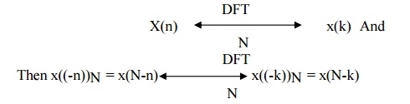

**Time Scaling** : Time Scaling deals with the effect on the frequency-domain representation of a signal if the time variable is altered.

**Time Shifting** : Time Shifting property states that a shift in time is equivalent to a linear phase shift in frequency. Since the frequency content depends only on the shape of a signal, which is unchanged in a time shift, then only the phase spectrum will be altered.



**Frequency Shifting(Modulation)** : Frequency shifting enables us to shift a signal to a different frequency, allows us to take advantage of different parts of the electromagnetic spectrum is what allows us to transmit television, radio and other applications through the same space without significant interference.



**Convolution** : The convolution theorem states that convolution in time domain corresponds to multiplication in frequency domain and vice versa:

x1(n)∗x2(n)⇔X1(ejω)×X2(ejω)

**Multiplication** : The Multiplication property states that if

x1(n)×x2(n)⇔X1(ejω)∗X2(ejω)

It means that multiplication of two sequences in time domain results in circular convolution of their DFT s in frequency domain.

**Perseval’s Theorem** :The Parseval's theorem states

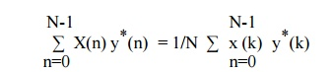

This equation gives energy of finite duration sequence in terms of its frequency components.

**Duality** : The Duality Property tells that if *x*(*t*) has a Fourier Transform *X*(*ω*), then if we form a new function of time that has the functional form of the transform, *X*(*t*), it will have a Fourier Transform *x*(*ω*) that has the functional form of the original time function (but is a function of frequency).  
